Ansible Work Flow Exercise

1. Create a Project
   1. Click Menu Button (Horizontal Lines)
   2. Choose Projects
   3. Name the Project (I am going to use “AZ Tech Day”)
      1. Add Description
      2. Organization = Default
      3. Default EE
      4. Source Control Type = Git
      5. Source Control URL = <https://github.com/Emergent360/tech_day>
      6. Choose: “Update Revision on Lanuch”
      7. Click on Save, then wait for a successfully sync.

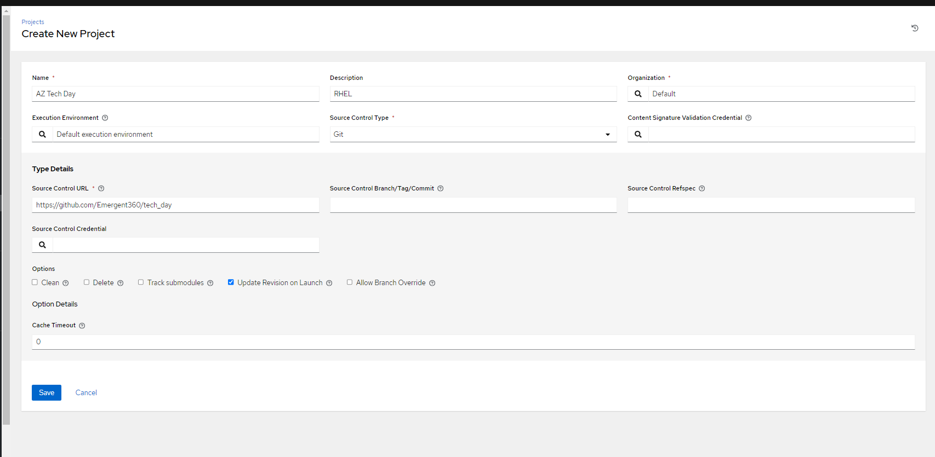

1. Let’s create Job Templates!
   1. Click on “Job Templates” tab and click the blue “Add” button.
      1. We will add a few job templates in this step. The steps to add are the same. Please be sure to name the Job Templates logically so that you can identify what the playbook will automate.
   2. Name the template.
   3. Add description if desired
   4. Job Type: Run
   5. Inventory: Workshop
   6. Project: Choose the Project you created in your previous step.
   7. Execution Environment: Default
   8. Choose Playbook
   9. Credentials: Workshop Credentials
   10. Click Save
   11. DO NOT LAUNCH THE JOB TEMPLATE!
   12. Rinse and Repeat to create Job Templates for the following:
       1. Security Updates
       2. Install Apache
       3. Reboot
       4. Enable Apache Services

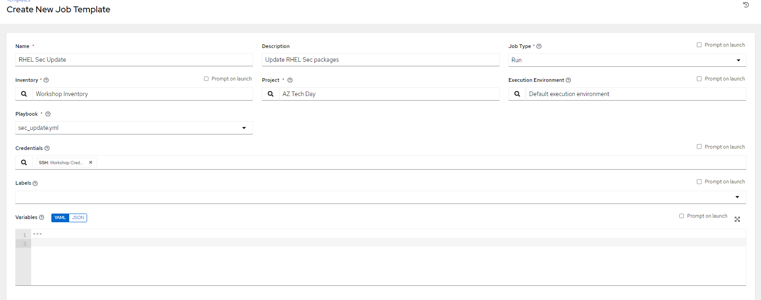

1. Let’s create a Workflow!
   1. Click on Templates from the Menu
   2. Click Add
   3. Choose “Add workflow template”
      1. Name the Workflow Template
      2. Add Description
      3. Organization: Default
      4. Inventory: Workshop Inventory
      5. Click Save
   4. You will be taken to a Visualizer Display. Click on the green Start Button.
   5. At the Add Node Prompt, choose your RHEL Security Update Job Template.
   6. Next, we will need to link another playbook, Let’s Choose the Job template that installs Apache.
      1. Hover over the Node and choose the plus sign. Use the option “On Success”
      2. Click Next
      3. Choose your job template that installs Apache. (Rinse and Repeat for the remaining Job Templates)
      4. Continue to link the Job Templates
         1. There is an option for “On Failure”, How would you use this?
      5. Launch the Workflow
      6. Watch for the green checks!